**Supporting Documentation for Dave Ackmann’s Application for the NMRA Electrical Engineering Achievement Program Certificate**

This document is intended to provide evidence of my qualifications for the Electrical Engineering Certificate in the NMRA Achievement Program. It is organized along the lines of the “Statement Of Qualifications” form for Electrical Engineering. As it is difficult during the COVID19 pandemic to get evaluators to my layout, the Baden, Vogt & DeSmet (the “BVD”), I have created links to movies to demonstrate my accomplishments. Just click on the links below to view each movie.  
  
**Layout Construction:**

* 1. 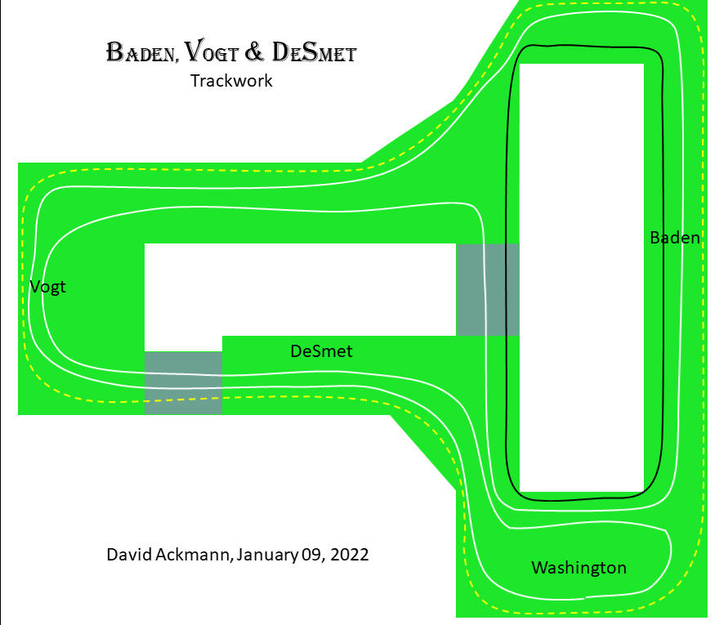**Track Plan and Electrical Power:** The BVD is HO scale, approximately 22’ by 22’, in the shape of an open “T”. The gray rectangles indicate lift gates.  
     As you can see from this gross illustration, my layout is designed for continuous running of trains in three electrically isolated, quasi-concentric loops; Sidings, crossovers, yards, and the reversing loop are omitted from this drawing for simplicity. I refer to the small black loop with the solid line as “Loop 1”, the solid white line as “Loop 2”, and the dotted yellow line as “Loop 3”.   
       
     For the complete track schematic, refer to section 4.
  2. My layout utilizes Digital Command Control from Digitrax. Here you see, from left to right, the Digitrax PS2012E Power Supply, a Booster (DB200+) and the combined Command Station and Booster (DCS 100). The booster in the center drives the inner and outer loops, and the Command Station and Booster on the right drives the middle loop (Loop 2) and most of the switch machines.

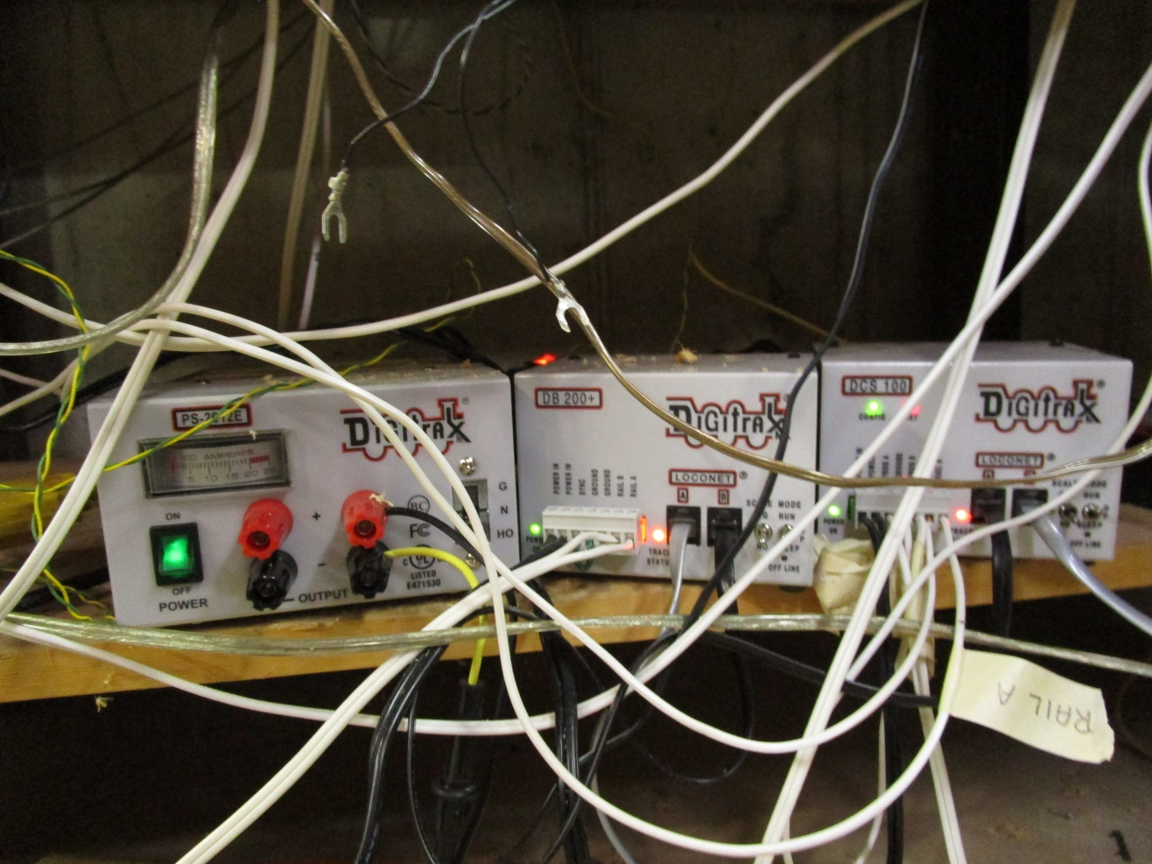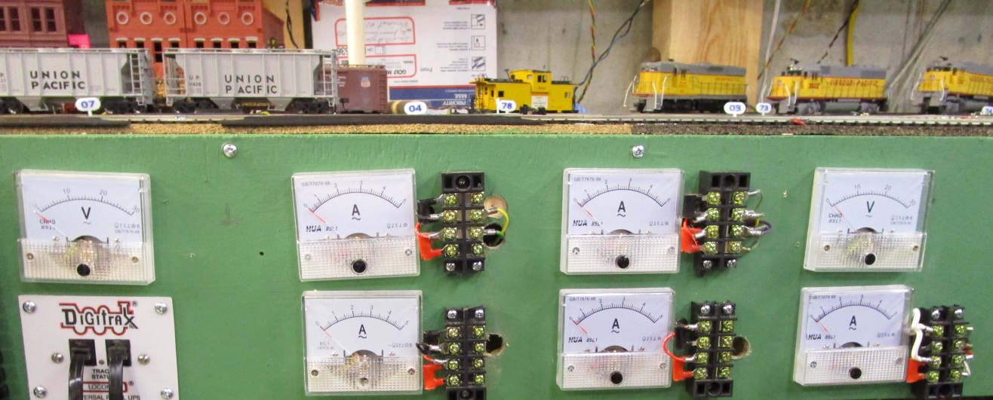The booster in the middle is connected to a Digitrax PM42 to manage power to different sub-districts.   
  
The Command Station on the right is connected to its own Voltmeter and Ammeter (the right column of meters); the booster in the center connected to its own Voltmeter (the single meter on the left), and the 4 power districts of the PM42 are connected to their own ammeters (columns 2 and 3, although only 2 of the 4 power districts, the upper meters, are used at this time).   
  
  
  
  
  
  
  
  
  
  
  
   
  
Although the three loops are electrically isolated by nylon rail joiners, all power is properly phased and allows complete interoperability between loops via crossovers.

* 1. **Reversing Loop:** Loop 2 of the BVD has a reversing loop. The reversing loop is electrically isolated from the rest of the layout. The reversing loop is entered when turnout #2 is closed, allowing the locomotive to enter. When the complete consist is in the loop, turnout #1 is flipped to allow the train to exit the loop. When the train has cleared the loop, switch #2 is returned to the “thrown” position to allow continuous running in Loop 2. To see the reversing loop in operation, [click here](https://youtu.be/eypkA3YgNy8).
  2. **Passing Siding:** The town of DeSmet has one of several passing sidings on the BVD. Entry and exit are controlled by turnouts #64 and #65. To see the passing siding in operation, [click here](https://youtu.be/gIW49r8hWuY).
  3. 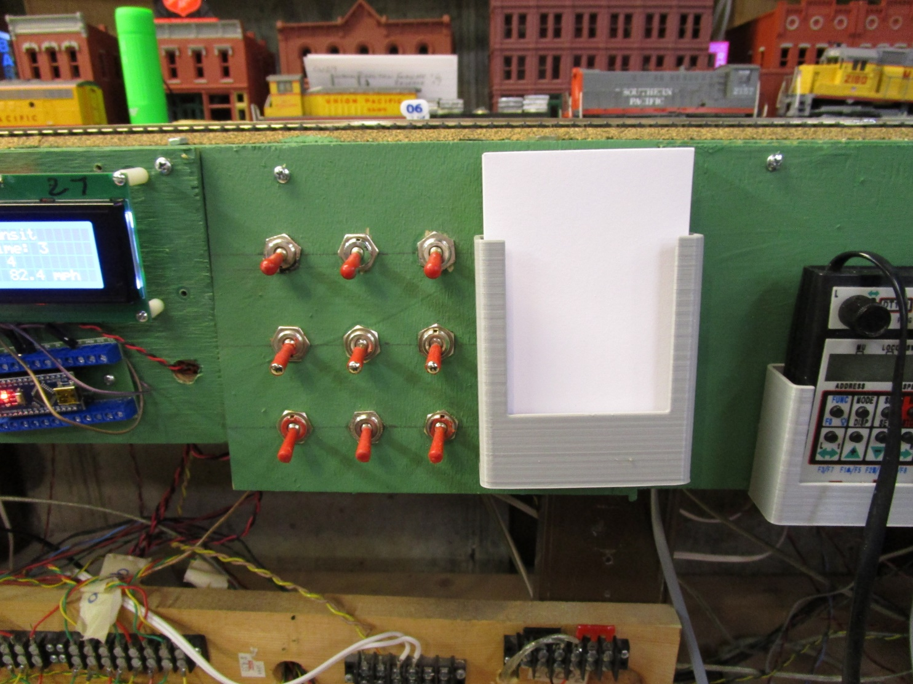**Locomotive Storage:** The East Yard is connected to Loop 3, and allows for locomotive storage. Both the North and South ends of the East yard have 3 spurs which are electrically isolated from the rest of the yard and the mainline of loop 3. Here you can see a switch matrix which control the spurs at the North end (left column), the switches that control the South end (right column), and the switches that control the sidings (center column). If you [click here](https://youtu.be/_gSsJZzdGPE), you can see the operation of these spurs for locomotive storage.
  4. **Yard and Switching Lead:** The South End of the East Yard is shown here. The yard lead is actually a siding independent of the mainline of Loop 3. To view switching of some freight cars in this end of the yard, [click here](https://youtu.be/uO0bvwnf9FY).
  5. **Power Supply and Circuit Protection:** The DCS 100 Command station provides automatic protection from short circuits by shutting down when one occurs. To see this protection in action, [click here](https://youtu.be/iJCytZcdr2g).

1. **Turnout Operation:**
   1. 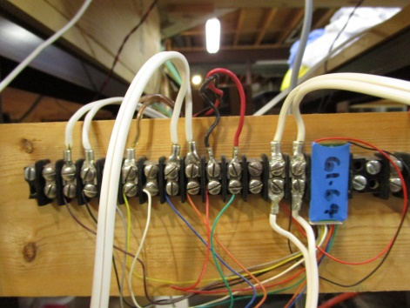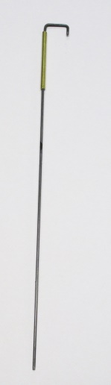**Simple Turnout:** There are about 70 turnouts on the BVD, and in the section 1.c above we demonstrated turnout #65 in operation controlling a siding in the town of DeSmet. Most of my turnouts are Atlas #4 or #6, and are thrown by Hankscraft can motors which are frequently used commercially to provide motion in marketing displays. Varieties of this motor run at different voltages and spin at different speeds, but I use ones that run on 12 volts, and turn at 4RPM, and even then I usually slow them down with a 330Ω resistor. They are designed to run continuously, even when stalled, without consuming any more than 20 milliamps of current.   
        
         
      My turnouts are controlled by Digitrax DS44 circuits, as shown here; it’s the blue piece of electronics labeled “61-64”, and has 2 wires for power at one end, and 8 wires for turnouts and one white wire for configuration at the other end. The DS44 can individually control up to 4 distinctly addressable turnouts, and can power up to 2 turnouts at each address.   
        
      After the Atlas turnout is laid into place, I construct a control lever to move the points. I take a 0.025” piece of stiff wire commonly used by Remote Control aircraft modelers for connecting servo motors to control surfaces, about 5” long, and bend it into a J. The short “nose” is about 1/8” long, and offset from the long side by about 3/8”. The short nose will go into the hole in the turnout throw bar, and the long side through a 0.035” brass bushing (1.25” long) and then through a hole in the layout drilled with a 5/64” bit. Once the long lever leg is inserted through the layout, it is bent such that it parallels the underside of the layout much as possible.

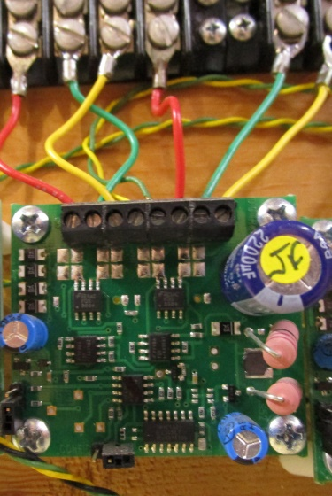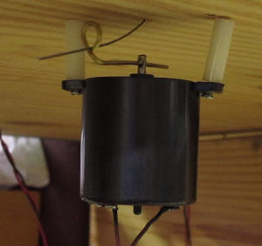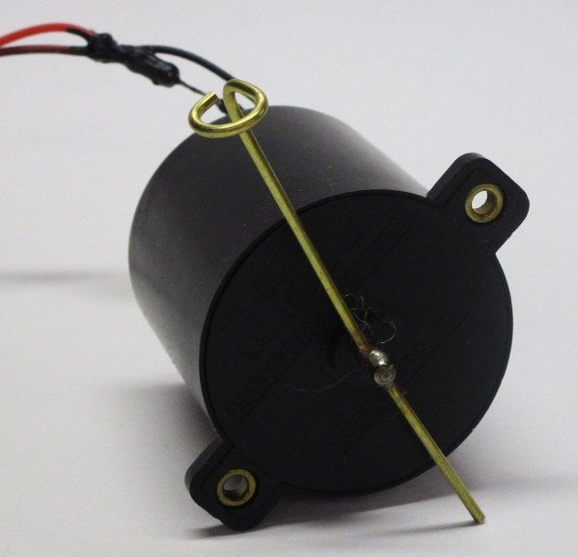The Hankscraft switch machine shaft has a 1/16” hole in it, into which I insert a piece of brass rod. I bend one end of the rod into a loop, and solder the rod to the shaft.   
  
  
  
  
  
  
  
  
  
To install the motor, I run the control lever through the loop in the brass rod, and attach the motor to the bottom of the layout with #4 screws I run through the mounting “ears” in the motor and 1 1/4" nylon standoffs I print on my 3D printer. I connect the wires from the motor to a Digitrax DS44   
  
  
  
  
  
  
  
  
  
  
Occasionally I use Atlas “snap switches” when space is limited, and these are controlled by Digitrax DS52 circuits; DS52 circuits are also capable of controlling slow motion switch machines, but are a bit more expensive per turnout than DS44 circuits.. Power and control signals for both the DS44 and DS52 circuits are obtained directly from the rails. To see an Atlas/Hankscraft motor in operation, [click here](https://youtu.be/APn0gC1UCVw).  
  
For a sample electrical schematic, refer to part 5.

* 1. **Single Crossover:** The BVD has several crossovers between loops. Here is one in the town of Vogt, where trains can cross between loops 2 and 3. It is controlled by a pair of Hankscraft switch machines and DS52 circuits as explained above. To view this crossover in operation, [click here](https://youtu.be/b4CDCHsgpLc).
  2. **Double Crossover:** I have 4 sets of Double Crossovers on the BVD. A Double Crossover is really nothing more than 2 pairs of Single Crossovers with a crossing in the middle. As is the case with most of my turnouts, they are powered by Hankscraft motors and in this case DS52 circuitry; each address on the DS52 is powering a pair of turnouts. To see one of the Double Crossovers between Loops1 and 2 in the town of Baden, [click here](https://youtu.be/WJB2oX5SK38).

1. **Electrical Features:**
   1. **Grade Crossing:** Moving north from the town of Baden there is a grade crossing protected by a pair of crossbucks with flashing lights. The signal is actuated when a train passes over a pair of light depended resistors embedded between the ties at either end of the protected track. Block occupancy is sensed by a Circuitron BD1 block detector and is independent of the DCC system. When a train enters the block, 12V power is applied to the circuitry which controls the flashers, a Busch HO5934. Power is provided to the BD1 from a 12 Volt “Wall Wart” through a regulated power supply which I constructed based on the design of similar power supplies from Circuitron. To view the grade crossing in operation, [click here](https://youtu.be/IEHEhgas1gg).
   2. **Sound in Locomotive:** UP locomotive 289 is a Walthers GP9M, part number 931-102. If you visit Walthers web site, by [clicking here](https://www.walthers.com/emd-gp9m-standard-dc-union-pacific-r-289-yellow-gray-red), you will see that nowhere in the description is sound mentioned; it’s not even DCC ready. But I had an unused Soundtraxx sound decoder for a diesel locomotive in my parts box, so I popped the shell and added sound to this locomotive. This was accomplished by cutting the wires between the power pickups and the motor, and then splicing the decoder in the middle, as described in the decoder instructions. The tricky part is finding space for the speaker, but I found space in the cab. Speakers always sound louder and better if a baffle is placed behind the speaker, and I created one with my 3D printer. To hear the final result, [click here](https://youtu.be/86mjR3jTzvM).
   3. **Other (Speedometer):** Perhaps my favorite pieces of Electrical Engineering on the BVD are the speedometers which are installed on each of the three loops of track. These are based on an Arduino microprocessor and the software I wrote myself. A photocell is imbedded in each loop of track, and when a train passes over, a timer is started. Lines within the code define the length of the loop and the scale of the layout. When the train again passes over the photocell, the program calculates the scale speed and displays the information on a small alphanumeric panel, and the whole operation repeats itself. Speedometers have proven useful in determining the effectiveness of maintenance and in speed matching for MU operation. To view the operation of a speedometer, [click here](https://youtu.be/8grOcxxvsTg).

1. **Schematic of Propulsion Circuitry**
2. **Schematics for Turnouts and Features**